**URL_Shorter**

URL shortening is a technique used to create a shorter, more manageable version of a long URL. This can be useful for sharing links on social media or in messaging apps, where character limits may apply. In Python, a URL shortener can be implemented using a library such as TinyURL or Bitly, which provide APIs for generating short URLs from long ones. The process typically involves making an HTTP request to the shortening service's API endpoint, passing in the long URL as a parameter, and then receiving a shortened URL in the response. The returned shortened URL can then be used in place of the original long URL

**Describe**

The code uses SQLAlchemy, an ORM library, to create a database to store the original URLs and the shortened URLs which is an sqlite3 database and is stored in the local file system.

==>It creates a Flask app and a SQLAlchemy object, which will be used to interact with the database.

==>It defines a URL model which is a Python class representing the URLs table in the database.

==>It has two fields, id and original_url, where id is a primary key and original_url is the original url that is stored in the database.

**Requirements**

Anaconda (envs)

Python == 3.9.2

Flask == 1.2.1

SQLAlchemy == 1.4.46

**Installation**

==> Pre-Requirement (Software)

Anaconda(Anaconda is a distribution of the Python and R programming languages for scientific computing, that aims to simplify package management and deployment)

Following the steps to install the URL shorter Web Application using Flask:

Step 1 : Clone the Github Repo

https://github.com/Balasubramaniam077/URL_Shorter.git

Step 2 : Open the Anaconda Prompt and Create the New Envs using the given comment Below

Conda Create -n "Project name" "Python Version"

Step 3 : Open the terminal into the cloned Folder or Direct enter the path by provide the cd Commend

cd or File path

Step 4 : Install all the requirements for the URL shorter project by providing the commend it will process and Install all the Pre-Requirements

pip install -r requirements.txt

Step 5 : After completion of Installation for Requirements Libraries run the Python code

python app.py

Step 6 : It takes Some time to process after completing the code the url will generate. Simply copy the url and apply in Browser it will open the Flask Web Application !!!

<http://127.0.0.1:5000/>

Step 7 : Finally the web application will appear on your Browser Simply copy and paste the Original URL. The application will give the Shorter URL for your usage!!

**Image Representation Result:**

Show Case: 1

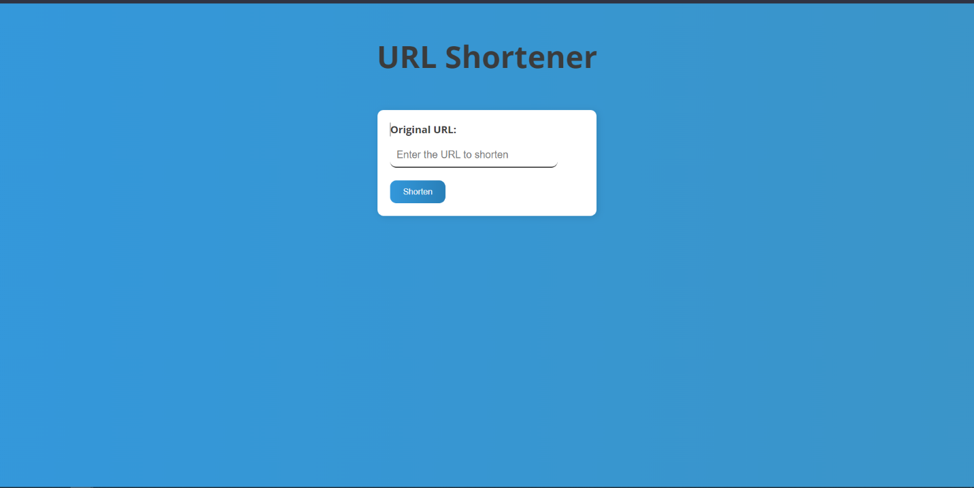

Show Case: 2

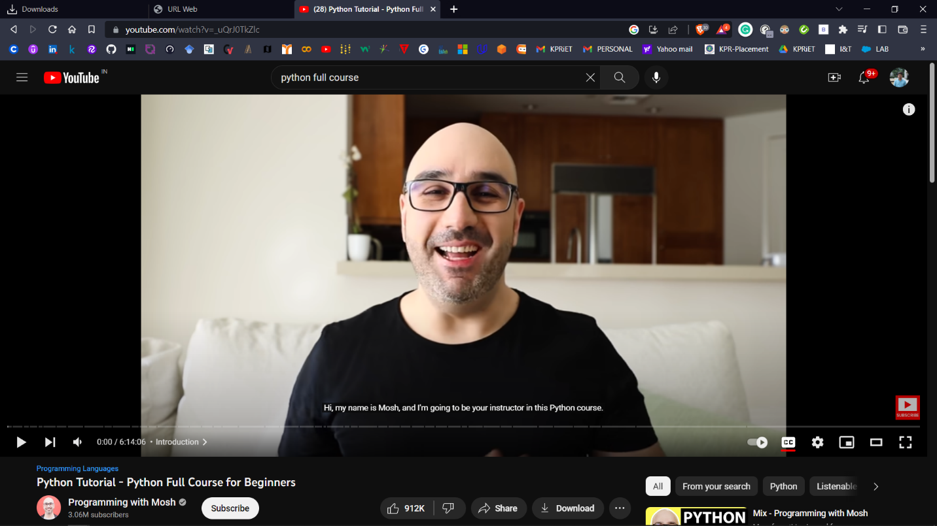

Showcase: 3

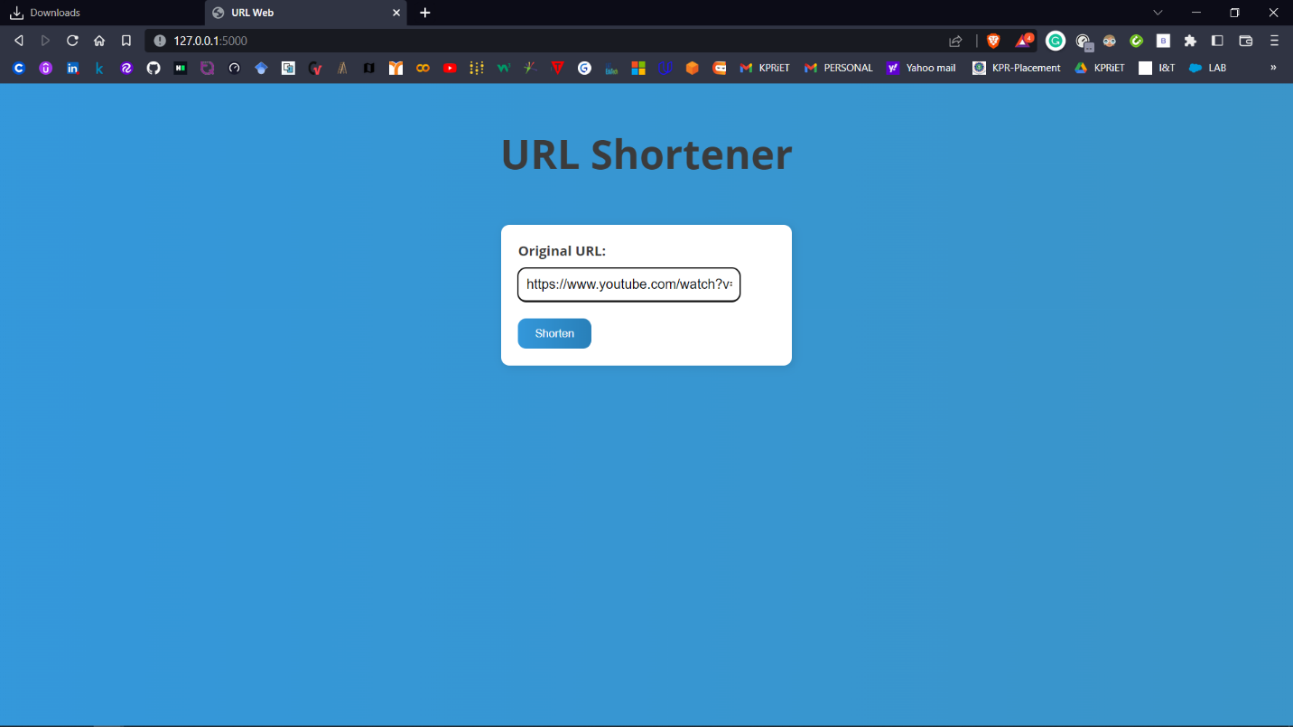

Showcase: 4

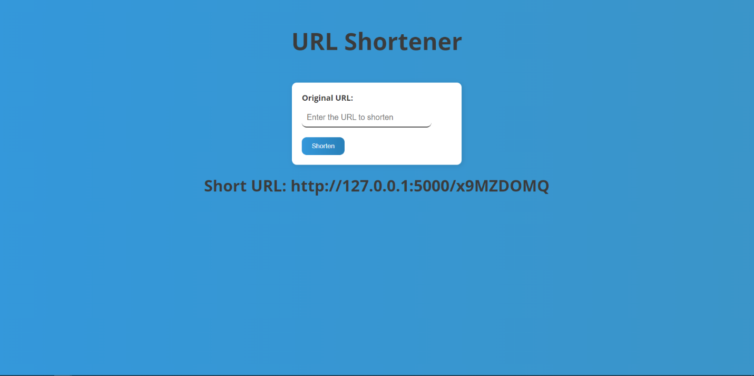

Showcase: 5

